**Introduction to Long Short-Term Memory(LSTM)**

LSTMs are long short-term memory networks that use (ANN) artificial neural networks in the field of [artificial intelligence](https://www.simplilearn.com/tutorials/artificial-intelligence-tutorial/what-is-artificial-intelligence) (AI) and [deep learning](https://www.simplilearn.com/tutorials/deep-learning-tutorial/introduction-to-deep-learning). In contrast to normal feed-forward neural networks, also known as recurrent neural networks, these networks feature feedback connections. Unsegmented, connected handwriting recognition, robot control, video gaming, [speech recognition](https://www.simplilearn.com/tutorials/python-tutorial/speech-recognition-in-python), machine translation, and healthcare are all applications of LSTM.

What is LSTM?

LSTMs Long Short-Term Memory is a type of RNNs Recurrent Neural Network that can detain long-term dependencies in sequential data. LSTMs are able to process and analyze sequential data, such as time series, text, and speech. They use a memory cell and gates to control the flow of information, allowing them to selectively retain or discard information as needed and thus avoid the vanishing gradient problem that plagues traditional RNNs. LSTMs are widely used in various applications such as [natural language processing](https://www.simplilearn.com/tutorials/artificial-intelligence-tutorial/what-is-natural-language-processing-nlp), [speech recognition](https://www.simplilearn.com/tutorials/python-tutorial/speech-recognition-in-python), and time series forecasting.

What is RNN?

RNNs Recurrent Neural Networks are a type of neural network that are designed to process sequential data. They can analyze data with a temporal dimension, such as time series, speech, and text. RNNs can do this by using a hidden state passed from one timestep to the next. The hidden state is updated at each timestep based on the input and the previous hidden state. RNNs are able to capture short-term dependencies in sequential data, but they struggle with capturing long-term dependencies.

Types of Gates in LSTM

There are three types of gates in an LSTM: the input gate, the forget gate, and the output gate.

The input gate controls the flow of information into the memory cell. The forget gate controls the flow of information out of the memory cell. The output gate controls the flow of information out of the LSTM and into the output.

Three gates input gate, forget gate, and output gate are all implemented using sigmoid functions, which produce an output between 0 and 1. These gates are trained using a backpropagation algorithm through the network.

The input gate decides which information to store in the memory cell. It is trained to open when the input is important and close when it is not.

The forget gate decides which information to discard from the memory cell. It is trained to open when the information is no longer important and close when it is.

The output gate is responsible for deciding which information to use for the output of the LSTM. It is trained to open when the information is important and close when it is not.

The gates in an LSTM are trained to open and close based on the input and the previous hidden state. This allows the LSTM to selectively retain or discard information, making it more effective at capturing long-term dependencies.

Structure of LSTM

An LSTM (Long Short-Term Memory) network is a type of RNN recurrent neural network that is capable of handling and processing sequential data. The structure of an LSTM network consists of a series of LSTM cells, each of which has a set of gates (input, output, and forget gates) that control the flow of information into and out of the cell. The gates are used to selectively forget or retain information from the previous time steps, allowing the LSTM to maintain long-term dependencies in the input data.

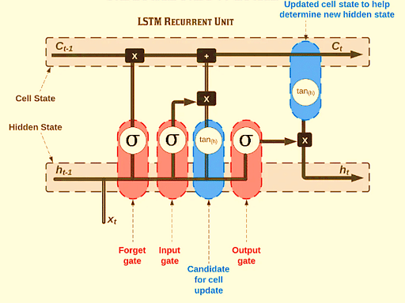

The LSTM cell also has a memory cell that stores information from previous time steps and uses it to influence the output of the cell at the current time step. The output of each LSTM cell is passed to the next cell in the network, allowing the LSTM to process and analyze sequential data over multiple time steps.

Applications of LSTM

Long Short-Term Memory (LSTM) is a highly effective Recurrent Neural Network (RNN) that has been utilized in various applications. Here are a few well-known LSTM applications:

* Language Simulation: Language support vector machines (LSTMs) have been utilized for natural language processing tasks such as machine translation, language modeling, and text summarization. By understanding the relationships between words in a sentence, they can be trained to construct meaningful and grammatically correct sentences.
* Voice Recognition: LSTMs have been utilized for speech recognition tasks such as speech-to-text-to-text-transcription and command recognition. They may be taught to recognize patterns in speech and match them to the appropriate text.
* Sentiment Analysis: LSTMs can be used to classify text sentiment as positive, negative, or neutral by learning the relationships between words and their associated sentiments.
* Time Series Prediction: LSTMs can be used to predict future values in a time series by learning the relationships between past values and future values.
* Video Analysis: LSTMs can be used to analyze video by learning the relationships between frames and their associated actions, objects, and scenes.
* Handwriting Recognition: LSTMs can be used to recognize handwriting by learning the relationships between images of handwriting and the corresponding text.